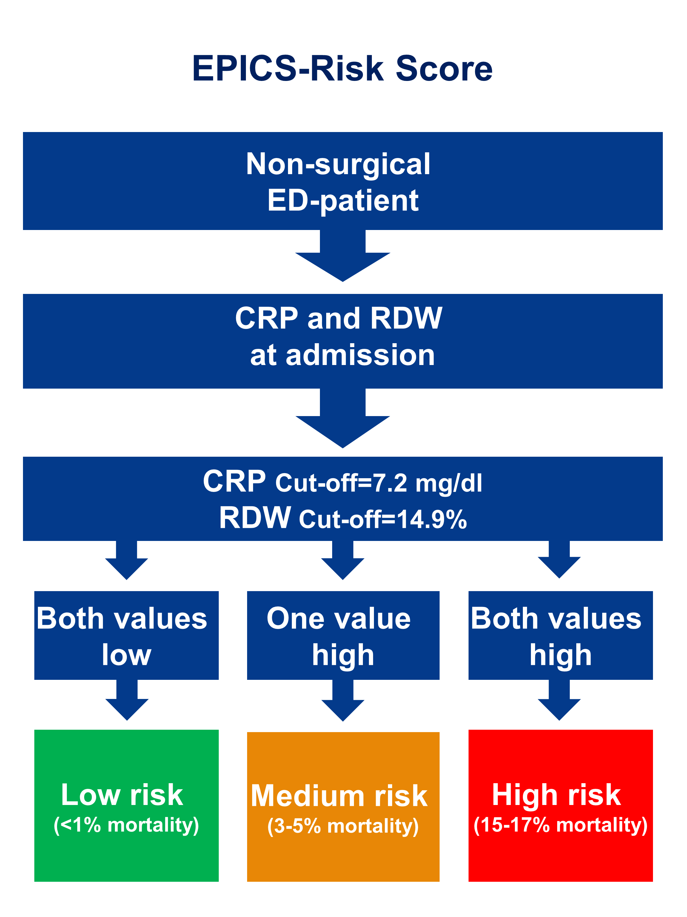

Supplementary Figure 1: Suggested score for the implementation of study results into clinical practice. This score needs to be validated in a prospective multicenter trial before clinical use can be

